**Visvesvaraya Technological University**

**Belagavi, Karnataka, 590 014.**



**AICTE Activity Point Programme on**

**“Doubling The Village Income”**

(Non-Credit Activity of 2 Weeks (80-90 hours))

Submitted in partial fulfillment of the requirements for the award of

**Bachelor of Engineering in**

**Computer Science and Engineering Semester IV**

**Academic Year 2019-20**

***Department of Computer Science & Engineering***

K. L. E. SOCIETY’S

**K. L. E. INSTITUTE OF TECHNOLOGY,**

Opp. Airport, Gokul, Hubballi-580 030

Phone: 0836-2232681 Website: [www.kleit.ac.in](http://www.kleit.ac.in/)

**Group Members**

|  |  |  |  |
| --- | --- | --- | --- |
| **Sl. No.** | **Site Name** | **USN** | **NAME** |
| 1. | DOUBLING THE INCOME OF VILLAGE USING SOLAR ENERGY | 2KE20CS049 | NIKHIL CHAVHAN |
| 2. | 2KE20CS052 | POOJA WADEKAR |
| 3. | 2KE20CS054 | POOJA BELGAUMKAR |
| 4. | 2KE20CS056 | PRADEEP TUMBINAVAR |
| 5. | 2KE20CS062 | PURUSHOTTAM BELLARY |
| 6. | 2KE20CS066 | RAJAT R KIRESUR |
| 7. | 2KE20CS069 | RAMYA KULKARNI |
| 8. | 2KE20CS075 | SAGAR BAGALKOTI |

**DOUBLING THE INCOME OF VILLAGE USING SOLAR ENERGY**

* 1. **INTRODUCTION**

India is blessed with a huge potential for solar energy. On an average, India receives 200 MW/km square of solar radiation per day. With almost 60 per cent of the population residing in the rural region, the solar industry has a massive market to explore. Much of rural India still lacks a regular electricity supply. As a result, dependency on conventional energy sources such as kerosene and coal is high in the rural region. Thus, the adoption of solar power in rural areas can not only reduce the use of fossil fuels but also result in the generation of clean and cheap energy. Further, there are many social and economic benefits linked to solar installations in rural areas. The fading light begins to slope and redden as evening approaches in Sitapur district, north-central Uttar Pradesh. As you journey here from the bustling city of Lucknow, you travel not only across space but time, too, into a medieval world of smoking wood fires, trundling bullock carts and mud-walled, straw-topped huts. There is little electricity here, and almost no access to clean water or basic sanitation. The summers are scorching and the winters frigid yet at this time of year, just after the rains, a cool breeze tousles the teeming grasses blissfully. Even this heavenly vision, though, veils the challenges that were brought to the region by heavy monsoon rains this season, which swelled the Ghaghara river’s banks to bursting point, inundating more than seventy villages and multiple croplands. Village by village, MGP are building a network of low cost solar micro-grids that provide two LED lights and a mobile charging point to all paying households at a cost of 25 rupees [US$0.5] per week. That is cheaper than the equivalent kerosene and mobile charging costs from the nearest town, which can be almost double across a month. Solar power, as a “smokeless” source of light, comes with added benefits to customer health. Installing a micro-grid is a grand event in the village and everyone gets involved. Here in the village of Damdampurawa, the team maps the village house by house beneath the scorching mid-day sun, working out where to place each wire so as to connect customers to the power source. Some householders joined in while others looked on, smoking a chillum, calling out orders, or watching the curious proceedings wide-eyed.

MGP maintains responsibility for these grids after they are installed. The only price the customers pay is for the connection and the energy itself, which they are provided with for seven hours each night. “This is an essential part of our model”, says Sandeep Pandey, their operations manager. “It’s designed not to place high price burdens on our customers, who are amongst India’s poorest”.

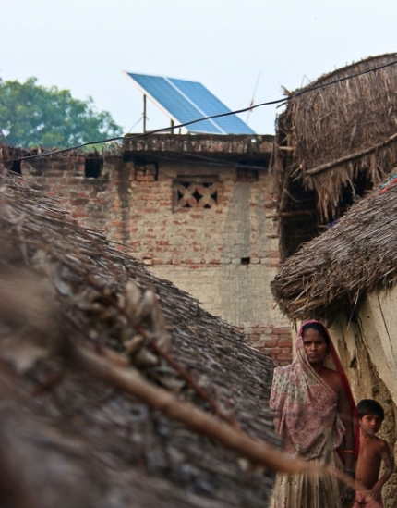

**1.1.1 Plan to double the incomes of India’s farmers. The measures of four point action**

**Plan includes:**

1. prices for farmers by reforming the existing marketing structure.
2. raising productivity.
3. reforming agriculture policy.
4. relief measures. An intimate dissection of point action is required.
   1. **LITERATURE SURVEY**

Erratic power supply affects much of India. Rural regions are especially affected by unreliable energy supply. As a result, much of the rural population is unable to match up with their urban counterparts. Alternatively, solar installations can be the answer to the woes of our rural population. Solar energy can offer better access to entertainment media like radio or television. It can also increase the overall productivity of an area due to the presence of solar-driven energy sources. In the near future, solar power in rural areas can prove to be a reliable source of energy. Large solar projects often require men and women for everyday operations and maintenance work. Usually, firms hire unskilled or semi-skilled labourers from the nearby villages. Usually, labours in rural regions depend on manual work and often lack modern skill sets. Solar projects can help drive new skill development and enable the labours to aim for higher income. Further, these projects also create various temporary employment opportunities. Solar power in rural India can also power other sectors in the community such as agriculture, pottery, weaving and carpentry. People can also seek employment and improve their skill sets in these sectors. Due to such projects, the economic health of the villages is growing.

Due to the above advantages, the use of solar energy in villages areas is experiencing a gradual surge. However, the road is long and challenging. The major hindrance is the lack of communication and awareness among the rural population. Technology will play a major role in this. Once the benefits of solar energy get communicated to rural India, the rest will be a matter of time.

* 1. **DATA RELATED TO PRESENT TIME**

Solar panels in rural areas can be a source of revenue as well. Solar projects can be a valuable means of income generation especially because the land is a vital component for such projects. Some solar developer lease barren lands that otherwise hadn’t been of any use. In this way, the rural communities are getting a stream of cash flow without any cost if investment. Further, such projects can also create jobs during as well as post-development phases in operation and maintenance areas. Opportunities for local workers and electricians are often hired during the development phases of solar projects. Moreover, solar projects may also create opportunities after the development phase such as for maintenance of the projects. Some of the common job roles in the post-development phase include cleaners, security personnel, gardeners, technicians and operators Solar Power Generation: The solar power village would be self-sufficient in solar energy generation, as it will utilise 1000 solar panels that have been installed on the village houses, generating electricity round the clock for the villagers.

It is developed through Ground Mounted Solar power plant and more than 1300 Rooftop solar systems on residential and Government buildings, all integrated with Battery Energy storage systems (BESS).

A BESS is a type of energy storage system that uses batteries to store and distribute energy in the form of electricity. Residents of the area will be able to save 60-100% of their electricity bills.

* 1. **APPROACH (AN IDEA TO THE INCOME)**

Large solar projects often require men and women for everyday operations and maintenance work. Usually, firms hire unskilled or semi-skilled labourers from the

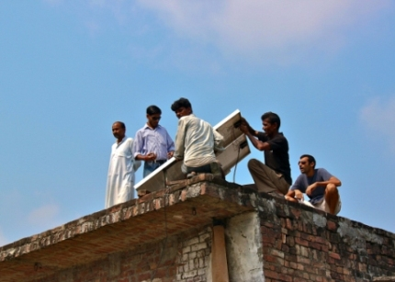

nearby villages. Usually, labours in rural regions depend on manual work and often lack modern skill sets. Solar projects can help drive new skill development and enable the labours to aim for higher income. Further, these projects also create various temporary employment opportunities. Solar power in rural India can also power other sectors in the community such as agriculture, pottery, weaving and carpentry. People can also seek employment and improve their skill sets in these sectors. Due to such projects, the economic health of the villages is growing.

Due to the above advantages, the use of solar energy in villages areas is experiencing a gradual surge. However, the road is long and challenging. The major hindrance is the lack of communication and awareness among the rural population. Technology will play a major role in this. Once the benefits of solar energy get communicated to rural India, the rest will be a matter of time.

The Cabinet Committee on Economic Affairs, chaired by the Prime Minister Shri Narendra Modi, has given its approval for the implementation of Phase-III of the off-grid and decentralized Solar PV (photovoltaic) Application Programme to achieve additional 118 MWp off-grid solar PV capacity by 2020. Phase-III of Off-grid and Decentralized Solar PV Application Programme covers the following components:

**Solar streetlights**: 300,000 numbers of solar streetlights will be installed throughout the country with special emphasis on areas where there is no facility for streetlighting systems through grid power, North-eastern States, and Left-Wing Extremism (LWE)-affected districts.

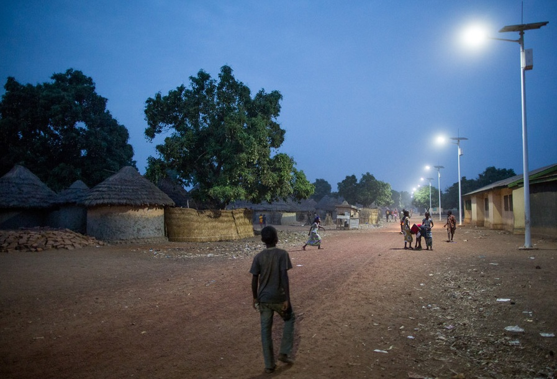

**Stand alone solar power plants:** Solar power plants of individual size up to 25 kWp will be promoted in areas where grid power has not reached or is not reliable. This component is mainly aimed at providing electricity to schools, hostels, panchayats, police stations, and other public service institutions. The aggregated capacity of solar power plants would be 100 MWp.

**Solar study lamps**: 2,500,000 numbers of solar study lamps will be provided in North-eastern States and LWE-affected districts. For solar streetlights and solar power plants, financial support up to 30% of the benchmark cost of the system will be provided except for the North-eastern states, hill states, and island UTs where up to 90% of the benchmark cost will be provided. For solar study lamps, only 15% of the lamp cost is to be borne by beneficiary student and balance will be provided as financial support as such systems will be provided to school-going children in backward and remote areas. The total project cost of the three components included under the Phase-III is 1,895 crore of which 637 crore will be provided as central financial assistance. The off-grid solar systems will also open better livelihood opportunities for beneficiaries in rural and remote areas, thereby increasing self-employment in such areas. It is estimated that, besides increasing self-employment, the implementation of Phase-III is likely to generate employment opportunity equivalent to 8.67 lakh man-days for skilled and unskilled workers. Off-grid and Decentralized Solar PV Applications Programme has high impact in the rural and remote areas of the country where grid power has either not reached or is not reliable. During the Phase-III, the programme is likely to benefit 40 lakh rural households. In addition, the off-grid solar power plants proposed in the programme to provide electricity to schools, hostels, panchayats, police stations, and other public service institutions will help communities at large and also help in increasing participation of women in education, social, and livelihood activities.

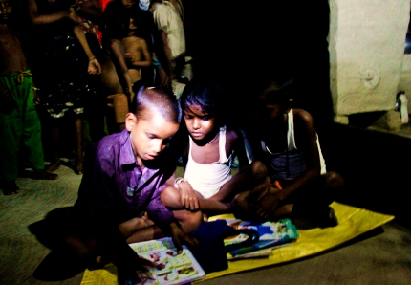

**1.5 KEY CHALLENGES**

WAYS TO INCREASE INCOME IN VILLAGE USING SOLAR ENERGY:

 India has set an ambitious target of achieving 100,000 megawatts of solar power capacity by 2022 as well as doubling farm incomes by the 75th year of Independence.

Both these targets can be a game changer for rural India if implemented in unison, suggests new research.

According to a recent study by New Delhi-based International Council for Research in International Economic Relations (ICRIER), access to solar power can help water crop fields, build cold storages and augment farm incomes by feeding the surplus power generated into the grid.

The paper titled Harvesting Solar Power in India further said that while farmers can earn guaranteed tariffs by feeding the surplus power into the grid—akin to harvesting a second or a third crop—solar-powered irrigation pumps will insure farmers when rains fail and also replace polluting diesel pumps.

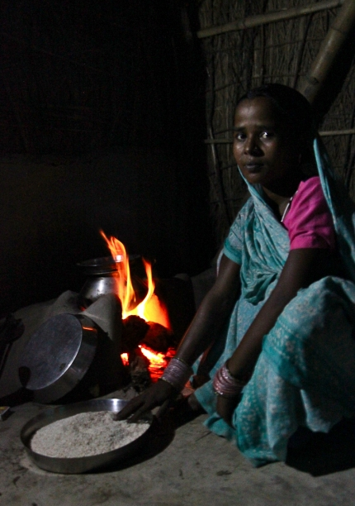

Indian farmers currently use more than 20 million diesel and electric pumps and replacing these with solar-powered ones can help reduce the annual power subsidy bill of the government to the agriculture sector, the paper said.

It added that solar pumps can save farmers more than ₹ 1 lakh in costs over a decade, due to high maintenance and fuel costs of diesel pumps.

According to the ICRIER paper, if farmers have the option of selling surplus power to the grid, then they would minimize water pumping and thus conserve water.

“This model would act as an incentive to adopt solar energy in the country, and reduce ground water exploitation and augment farmers’ income," the paper said.

Government data shows the leaps India is taking in this direction. Till March 2015, it had installed 19,500 solar pumps, but during 2015-16 alone, 31,472 solar pumps were installed across the country.

“This definitely is a boon for remote rural and agriculture areas without any power access as well as sparse electricity supply," the paper said, adding, “it would be a useful and innovative policy solution to connect such decentralized renewable systems to the grid for additional revenue generation for farmers."

The paper cited the success story of Dhundi Saur Urja Utapadak Shahakari Mandali in Gujarat as the first solar irrigation cooperative in the world where farmers are selling surplus solar power to discoms.

However, according to the paper, high upfront capital costs of ₹ 3-5 lakh for installing solar pumps could be a challenge that has to be overcome by providing credit on easy terms.

Besides using solar pumps, farmers could also benefit by leasing crop lands for installing solar panels, while simultaneously harvesting crops, the paper said. “It is like having a second crop of solar power at a height of 15-20 feet with the food crop below on the field," the study said, adding, “studies across the globe have proved that shade of solar panels have no negative impact on crop growth, if arranged in a particular configuration that allows sufficient sunlight and wind to pass through to the plants."

Both the agriculture ministry and the ministry of new and renewable energy have to act in unison to achieve the twin goals of doubling farm incomes and meeting India’s solar energy generation targets by 2022, the paper advised.

* 1. **STRATEGIES :**

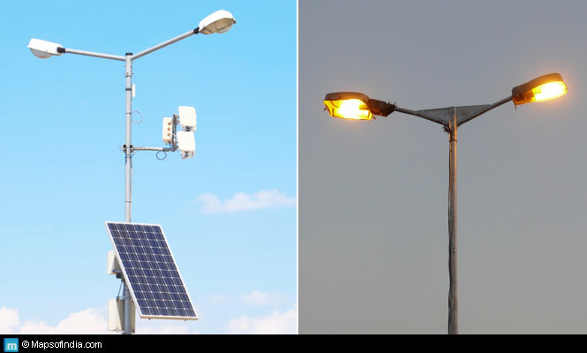

**COST OF IMPLEMENTING THE SOLAR ENERGY**

Solar Energy System consists of 4 main components that decide the working of a solar energy system.

* Solar Panel
* Solar Inverter
* Solar Battery
* Panel Stand, and
* Solar Panel Installation Accessories

Solar Energy Systems are of different types and can be used as per your needs and location. The 2 types of Solar Energy System are:

* Solar Panel with Battery (Off Grid Solar System)
* Solar Panel without Battery (On Grid Solar System)

Note: A Solar inverter is the main component of both the systems. While we install a solar energy system, we generally buy the following products

As of November 2021, manufacturing capacity of solar cells and solar modules in India was 4.3 GW and 18 GW, respectively. Nearly 80 percent of solar-panel's weight is flat glass. 100-150 tons of flat glass is used to manufacture a MW of solar panels. Low-iron flat or float glass is manufactured from soda ash and iron-free silica. Soda-ash manufacturing from common salt is an energy-intensive process unless it is extracted from soda lakes or glasswort cultivation in alkali soil. To increase installation of photovoltaic solar-power plants, the production of flat glass and its raw materials must expand commensurately to eliminate supply constraints or future imports.

The Ministry of New and Renewable Energy (MNRE), India, has issued a memorandum to ensure the quality of solar cells and solar modules.Compliance with the requisite specifications will grant manufacturers and their specific products an entry in the ALMM (Approved List of Models and Manufacturers.) Indian manufacturers are gradually enhancing the production capacity of monocrystalline silicon PERC cells to supply better performing and enduring solar cells to local market.

For utility scale solar projects, top solar module suppliers in 2016-17 were: Waaree Energies Ltd., Trina Solar, JA Solar, Canadian Solar, Risen, and Hanwha.

**1.7 REFERENCES**

* <https://www.loomsolar.com/blogs/collections/solar-panel-installation-cost-in-india>
* <https://www.livemint.com/Politics/LKa7Z0IvJEAhCeD8EbgMLN/Harvesting-solar-power-could-propel-growth-in-farm-income.html>
* <https://www.drishtiias.com/daily-updates/daily-news-analysis/india-s-first-solar-powered-village>
* <https://www.thethirdpole.net/en/energy/solar-power-transforms-the-lives-of-indian-villagers/>
* <https://www.genusinnovation.com/blogs/solar-power-in-rural-areas>

